Our Epidemiology Experience
What happens when you combine three educators, twenty-five middle school students and epidemiology? You have one creative, exciting, interactive, educational and fun summer camp! Our Epidemiology Camp was held July 28 through August 1, 2008 at the Clarion University Health Science Education Center, in Clarion, Pennsylvania. Over the five days of camp, the students became disease detectives. The lessons each day were based on the structural framework of five enduring epidemiologic understandings:
- Health-related conditions and behaviors are not distributed uniformly in a population. Each has a unique descriptive epidemiology that can be discovered by identifying how it is distributed in a population in terms of person, place, and time. Descriptive epidemiology provides clues for formulating hypotheses.
- Causal hypotheses can be tested by observing exposures and diseases of people as they go about their daily lives. Information from these observational studies can be used to make and compare rates and identify associations.
- Causation is only one explanation for finding an association between an exposure and a disease. Because observational studies are flawed, other explanations must also be considered.
- When a causal association has been identified, decisions about possible disease prevention strategies are based on more than the scientific evidence. Given competing values, social, economic, and political factors must also be considered.
- The effectiveness of a prevention strategy can be evaluated by making and comparing rates of disease in populations of people who were and were not exposed to the strategy. Costs, trade-offs and alternative strategies must also be considered.
Each day the students were given questions that they had to solve through hands-on experiences and investigations to demonstrate the understandings.
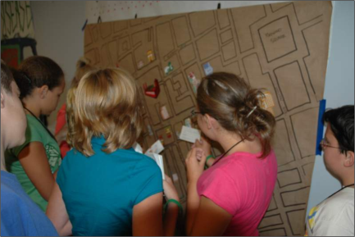
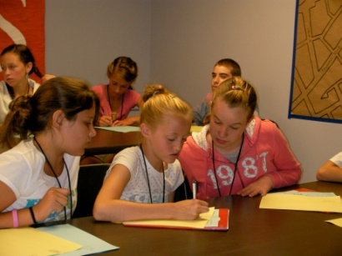
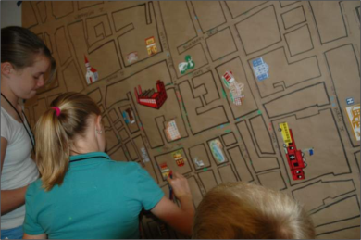
What is happening to the people of Fruitree Town? The disease detectives were told about a recent sickness in this community and they were to describe the distribution in terms of person, place, and time, look for patterns, and discover the agent, environment and host of this disease. A map of Fruitree Town and interview cards for over 250 townspeople which listed: name, occupation, age, address, date of onset, death date and recent activities were given to the disease detectives. Once the detectives narrowed the location of the outbreak to the Peach Tree Café, they were given the patron list containing each customer’s meal choice. The students were able to calculate and compare the incidence of the disease among those who did and did not consume each of the food items and were able to identify a link between the disease and drinking the water at the café. The detectives then researched the agent to discover cholera caused by contaminated drinking water. Teach Epidemiology instructor, Mark Kaelin, was available to assist the detectives in their research and to describe the relevance of epidemiology in their daily lives.
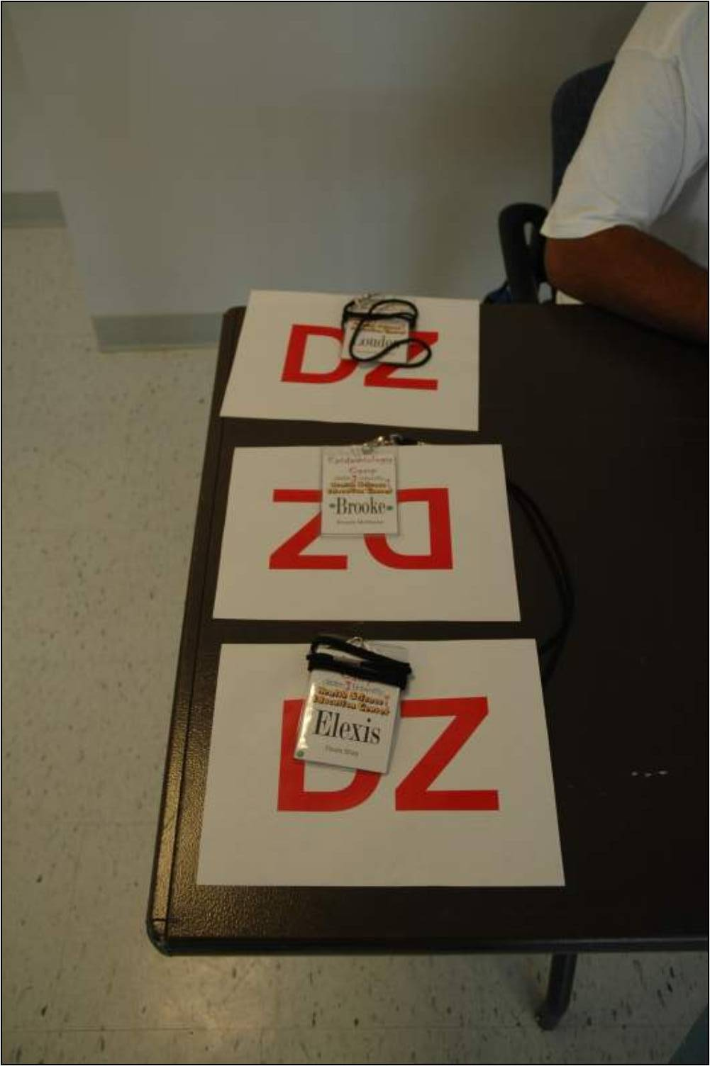
Why are these students getting sick? Each day particular students were confronted with a different pattern of a fictitious disease depicted with “DZ” signs. The class had to work together and use their understanding of the value of descriptive epidemiology to formulate hypotheses that might explain a particular distribution of “DZ.”
The ants go marching 2 by 2, Hooray! Hooray! ... but what about their backpacks? The detectives learned about and used 2 by 2 tables to calculate the risk of back pain associated with carrying heavy backpacks. The detectives gathered items that they normally would carry in their backpacks in order to estimate their backpack’s weight. They used this information to determine if there was an association between carrying a heavy backpack and back pain and then suggested possible risk management strategies for back problems associated with heavy backpacks.
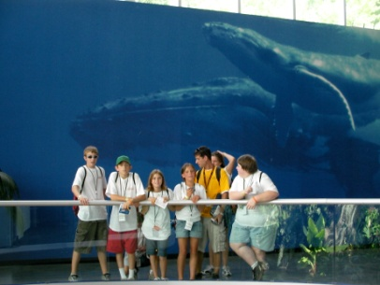
What causes outbreaks of diseases in animals? Our Epidemiology Camp campers traveled to Pittsburgh Zoo to discover diseases associated with zoo animals. The detectives were given a zoo passport that contained Epi questions they answered throughout their stay at the zoo and demonstrated their grasp of the understandings.
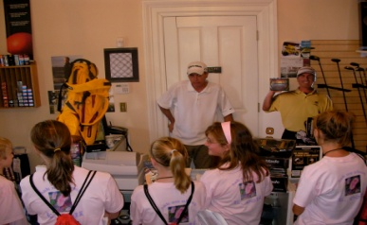
What’s happening in Clarion? The last day of camp was “interrupted” by an alert from CDC that an outbreak of a mysterious ailment was occurring in Clarion. The students were given the symptoms of the disease and the names with a short biography of each person being treated at Clarion Hospital. The detectives evaluated the symptoms and the data of the people being treated and determined what additional information they would need to solve this epidemic, and then journeyed throughout Clarion’s downtown businesses to interview friends and family members of those who were ill in order to fill in the missing pieces to the case. After collecting their data through personal interviews, the students hypothesized about and researched the possible cause of the outbreak.
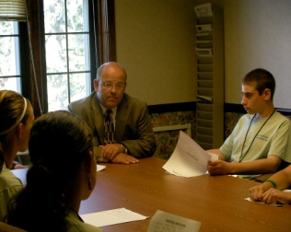
This activity allowed the detectives to get a real-life perspective of what an epidemiologist does and how epidemiology is important to our society. The students also had to use the epidemiologic-thinking skills they developed throughout the week in order to solve the mystery.
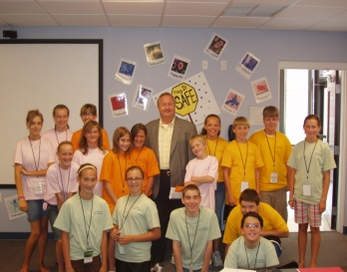
The epidemiologists-in-training presented their outbreak findings to President Joseph Grunenwald of Clarion University. President Grunenwald thanked the students for their research. He also discussed the importance of higher education, the study of epidemiology and other science fields.
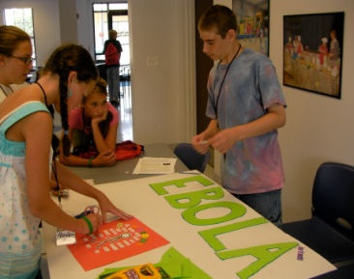
On the first day of camp, the disease detectives had been separated into groups to research one of the following diseases: Avian Flu, E. coli, Salmonella, Strep A, and Ebola. The campers then created a poster describing their groups’ disease. The student groups worked on their research project throughout the week at camp and presented their findings creatively to an audience of their parents and peers the last day of camp.
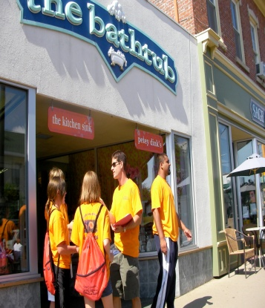
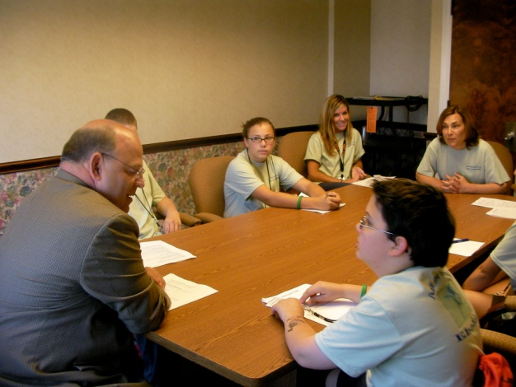
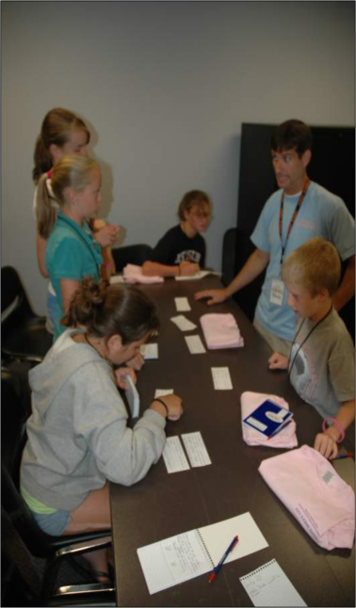
The E. coli group investigating the interview cards from the people of Fruitree town.
The Salmonella group is visiting one of the local businesses to interview their employees about the “outbreak” in the community.
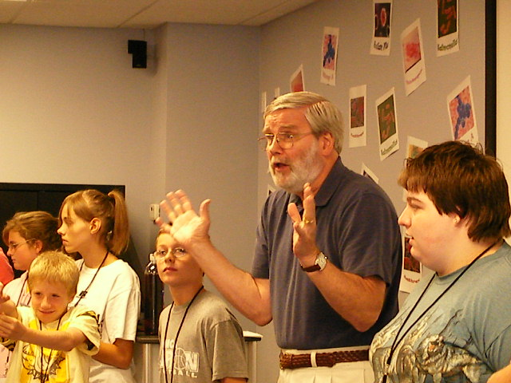
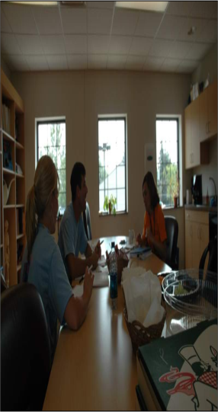
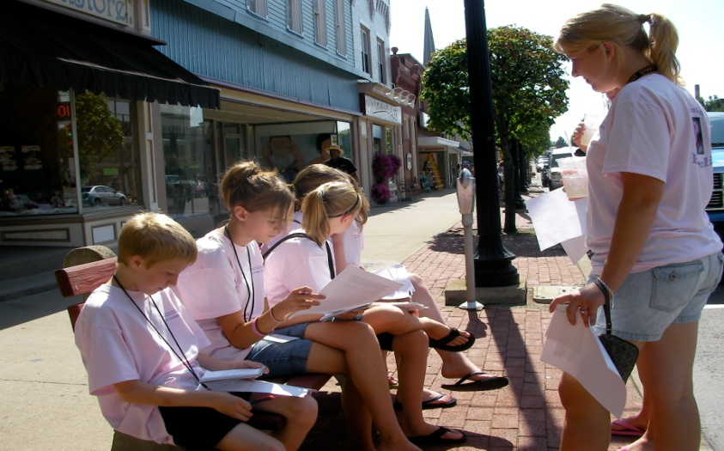
The Ebola group meeting with Clarion University’s Harry Trip about the “outbreak” in Clarion area.
Director Nancy Falvo, Associate Director Ron Radaker and Health Educator Angie Harriett are debriefing after the first day of Epi camp.
The E. coli group is collaborating and examining the information given to them by their interviews in the Clarion Area community about the “outbreak.”

