Epidemiology and the Energy Balance Equation

CROSS-SECTIONAL STUDY NOTEBOOK*

(MODULE 2)

* The cross-sectional studies that students plan and conduct in this Module are simulated research, not actual research, because they will not produce generalizable knowledge. The student experiences are intended for educational purposes only, to encourage innovation and problem-solving in a simulated research setting.

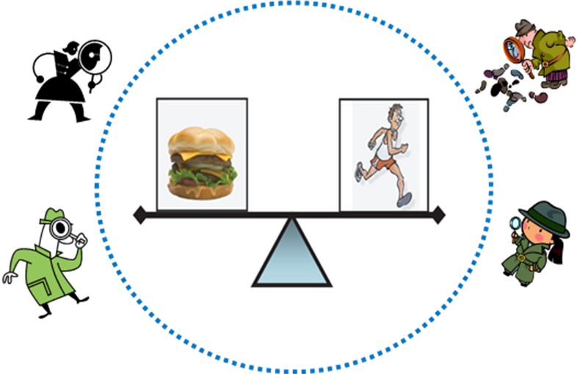
Updated Aug 29, 2011
Module 2 Enduring Understanding
Epidemiology and the Energy Balance Equation]
Module 2 Authentic Performance Tasks
Causal hypotheses can be tested by conducting investigations of the exposures and outcomes of selected groups of people as they go about their lives. Information from these observational studies can be used to determine if an exposure and an outcome are associated. Because observational studies are complicated by factors not controlled by the observer, other explanations also must be considered.
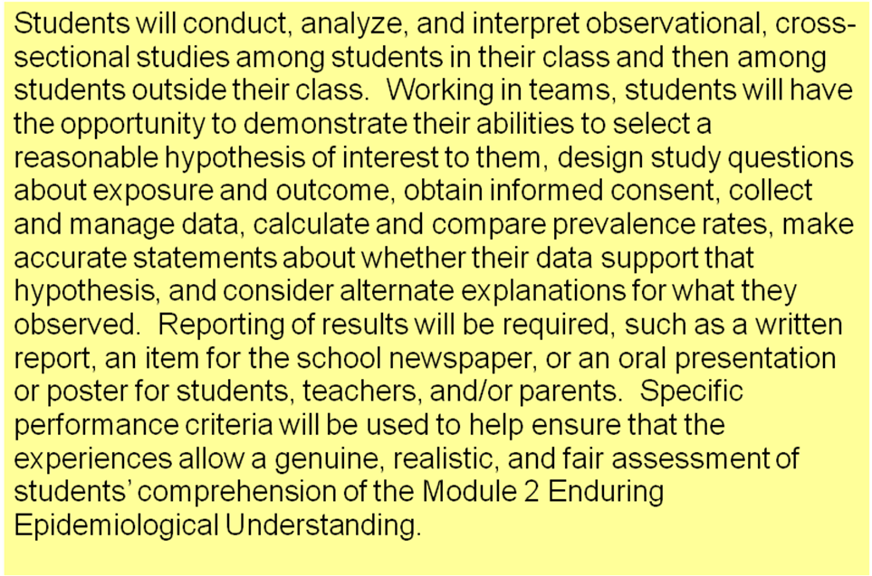
-1
Table of Contents
Meaning of "Association" *

 | Page
Lesson 2-1 Looking For Associations (No worksheets)
Lesson 2-2 Cross-Sectional Studies (No worksheets)
Lesson 2-3 Developing Hypothesis and Study Questions
2-3a Checklist - Study Planning Components and Expectations | 4
2-3b Study Hypothesis | 5
2-3c Study Variables: Questions about Exposure and Outcome and Additional Questions | 6
2-3d Sample Questionnaire for Cross-Sectional Study | 9
Lesson 2-4 Respect – Part II
2-4a Developing an Informed Consent Script for a Cross-Sectional Study | 10
2-4b Self-Assessment of Draft Informed Consent Script | 11
Lesson 2-5 Planning Study Conduct
2-5a Assignments for Day of Study | 12
Lesson 2-6 Cross-Sectional Study - In Class
2-6a Data Management and Calculations for In-Class Cross-Sectional Study | 13
Lesson 2-7 Cross-Sectional Study - In School
2-7a Data Management and Calculations for In-School Cross-Sectional Study | 16
2-7b In-School Cross-Sectional Study: Analysis by Gender | 18
2-7c Report, Poster, or Presentation | 21
2-3a
Checklist - Study Planning Components and Expectations

 | # | Study Plan Component | Met | Some-what Met | Not Met
 | 2-3 | Study Hypothesis - Statement of a hypothesized association between an exposure and an outcome  - 1) Stated clearly; 2) makes sense at face value; and 3) is feasible to study in a school setting | □ | □ | □
 | 2-3 | Study Variables - Developing questions about exposure and outcome  - 1) Clear questions that will mean the same thing to anyone who reads it; 2) a good description of what you are trying to measure; 3) a good understanding of challenges in measurement; and 4) an awareness of other information about study participants that will help in understanding study results | □ | □ | □
 | 2-3 | Questionnaire - Preparing a one-page sheet that study participants will fill out (typed and copies made)  - Format of the survey that is user-friendly and clear in presenting questions and answer options and instructions | □ | □ | □
 | 2-4 | Draft Informed Consent Script - Preparing a script to be read to possible study participants (typed and copies made)  - Appropriately filled-out sections of script template and any additions as appropriate | □ | □ | □
 | 2-5 | Plans for Study Conduct – Having assignments for study day  - A reasonable plan for: 1) approaching potential study subjects; 2) reading the informed consent script: 3) guiding study participants if they have questions; and 4) responsible gathering of completed questionnaires | □ | □ | □

2-3b
Study Hypothesis

1. State the hypothesis your study team has selected.

________________________________________________________________________

________________________________________________________________________
________________________________________________________________________

2. Answer the following questions in the space provided.

- Why is your study team interested in testing this hypothesis?

- Discuss the reason(s) your team thinks it will be possible to test this hypothesis in your class and school.

2-3c
Study Variables: Questions about Exposure and Outcome and Additional Questions

Exposure

- Create a question, that can be answered with a YES/NO or other two-answer option, to gather data about your EXPOSURE. (Speak with your teacher if you wish to use a multiple choice question.)

- Define/describe what you want your EXPOSURE variable to measure. Be as specific as you can. Think about challenges in measuring the exposure you want to measure, and go back to your exposure question and edit as needed.

2-3c (continued)

Outcome

- Create a question, that can be answered with a YES/NO or other two-answer option, to gather data about your OUTCOME. (Speak with your teacher if you wish to use a multiple choice question.)

- Define/describe what you want your OUTCOME variable to measure. Be as specific as you can. Think about challenges in measuring the outcome you want to measure, and go back to your outcome question and edit as needed.

2-3c (continued)
- 2x2 Table
Fill in the two boxes in the table below, to label your 2x2 table that will show how your exposure and outcome variables will be analyzed in order to test your hypothesis. (Note: if you plan to use multiple choice questions for your exposure and/or outcome, determine cut points for the data so that you can fill in the contingency table below.)
Write Exposure variable here | Write Outcome variable here
Write Exposure variable here | YES | NO | Total
YES | a | b
NO | c | d
Total

Questions to Gather Additional Information on Participants

- Think about what other information about students in your study would be interesting to know about, in terms of your hypothesis. (Hint: perhaps gender would be one of these)

In the space below, write any additional questions for your questionnaire that will gather information about these other characteristics of your study subjects.

2-3d
Sample Questionnaire for Cross-Sectional Study

For Office Use Only

Thank you for your participation in this survey. Please answer the questions below by circling one choice for each question. When you are finished, fold this paper in half and follow instructions for handing in your questionnaire.

Remember: Do not write your name anywhere on this paper.

Study Questions: (Circle one answer for each question)

1. During the past month, did you usually eat 3 or more servings of fruits/vegetables
per day?
Yes No

2. In the last semester that you have completed, did you have a grade average of A or B?

Yes No

3. What is your gender?

Male Female

4. What grade are you in?

5th grade 6th grade 7th grade 8th grade

2-4a
Developing an Informed Consent Script for a Cross-Sectional Study

My name is ___________________________ and I am participating in the conduct of a brief survey among students in our school. The survey is about behaviors that may affect your health.

To conduct this survey, I would like you to consider completing a brief questionnaire. It has ________ questions and will take approximately __________ minutes to complete. We would like to ask you some question regarding ___________________________ and ________________________________.

This study is being carried out for educational purposes only. It is not an actual study from which firm conclusions will be made.

If there are any risks assumed by participating, they are no greater than those you encounter in daily life. There are no benefits to you for participating and there is no compensation.

DO NOT write your name on this survey. The answers you give will be kept private. No one will know what you write. To further protect your privacy, all questionnaires will be destroyed at the end of the analysis.

Our study team wants you to know that your participation is voluntary, and that you can stop participating at any time without consequence. If you are not comfortable answering a question, just leave it blank. You can refuse to participate now; you can change your mind after starting to participate; or, after completing the survey, you can decide not to submit it.

Make sure to read every question. Circle one answer for each question. When you are finished, fold your paper in half so your answers cannot be seen, and wait for us to collect the surveys.

Do you have any questions?

Thank you very much for your help.

2-4b
Self-Assessment of Draft Informed Consent Script

Directions:
- Attach the revised Informed Consent Script for your cross-sectional study.
- Perform a self-assessment of your Script using the table below.

Did the script offer an explanation or answer for each of these topics?

CRITERION – Did the script offer an explanation or answer for each of these topics? |  | MET | SOMEWHAT MET |  | NOT MET
Elements of Informed Consent According to the Belmont Report
Purpose of the study

What study participants will experience

Any reasonably foreseeable risks to the individual

Potential benefits to the individual

Potential benefits to others

The extent of confidentiality protections for the individual

Compensation for participation (may include money, other material compensation, such as a coupon or gift certificate, or other non-monetary rewards)

Contact information for questions regarding the study, participants’ rights, and in case of Injury

The conditions of participation, including right to refuse or withdraw without penalty

2-5a

Assignments for Day of Study

 | Study Conduct Step | Responsible Person(s)*
1 | Set the date and time of the study, and provide any necessary prior notification to teachers, students, and others. (for in-class study – Lesson 2-7) | (teacher)
2 | Make Final Preparations for Study Team:  - Practice reading the Informed Consent script.  - Be sure there are enough hard copies of the study questionnaire.  - Have enough sharpened #2 pencils and a large  envelope for collecting the folded questionnaires.
3 | Conduct Cross-Sectional Study:  - Introduce team  - Read informed consent statement and remind class of their right to not participate.  - Review questionnaire with the entire class  + Read over all the questions  + Remind them to NOT write their name on the paper  - Instruct participants to voluntarily and anonymously fill out the questionnaire.  - When they are finished, instruct students to fold their paper in half and to put the paper into the large envelope that will be passed around (participants and non-participants should do this)  - Thank participants.
4 | Determine a secure safe place to keep questionnaires.
5 | Sort all questionnaires according to instructions to be described in Lesson 2-6 (or 2-7). Have at least one other person double check accuracy of assigning cell a, b, c, or d.
6 | Perform all data analyses and interpretation according to instructions to be described in Lesson 2-6 (or 2-7). Have at least one other person check accuracy of all calculations.
7 | Shred questionnaires after completion of analysis and report-out.

* Write "Study Team" or names of specific members of the team who are responsible for each step. Most steps should include every person on the study team in one way or another. Indicate details about this in the right column of the table. All members of the study team should be familiar with each step and ready to provide any help needed to complete.
2-6a
Data Management and Calculations for the In-Class Cross-Sectional Study

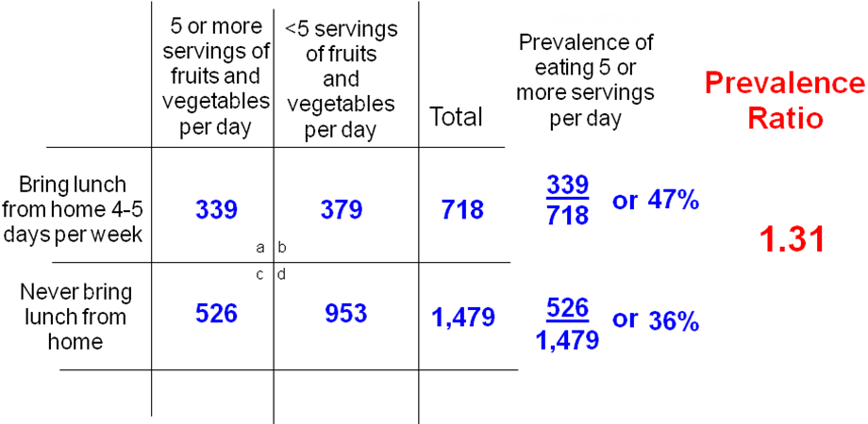
Review this sample 2x2 table and calculations before you start sorting your surveys and performing your calculations

Hypothesis for your study: ___________________________________________________

__________________________________________________________________________

- Unfold all surveys.

- Based on the responses to the first two questions on your surveys (exposure and outcome), sort surveys into four piles. Fill in the numbers below. NOTE: any surveys that do not have answers for both exposure and outcome should be set aside and not included in any analysis.

- How many answered YES/YES? #_________

- How many answered YES/NO? #_________

- How many answered NO/YES? #_________

- How many answered NO/ NO? #_________

TOTAL #_________

- Next, determine which response combination belongs in each cell. Draw arrows from each cell to the appropriate combination of exposure (YES/NO) and outcome (YES/NO).
YES / YES
NO / NO
YES / NO
NO / YES

cell a
cell b
cell c
cell d

Now write the correct letter (a, b, c, or d) in the box in the upper-right hand corner of each survey in all of your four piles.

- Label the 2x2 table below with the exposure and outcome in your study.

- Transfer the counts for each pile into the appropriate cells (a, b, c, or d) in the table below, and also fill in the boxes for "Total" for each row.

- Calculate the prevalence rates and prevalence ratio and fill in the table.

 | Outcome - YES | Outcome – NO | TOTAL | Prevalence Rate | Prevalence Ratio
Exposure - YES | a | b
Exposure - NO | c | d

- Complete this statement: The exposed group was _______ times as likely to have the outcome as the unexposed group.

- Explain whether or not the data support your hypothesis.

- Explain why you think you found the association (or lack thereof) that you did.

- How did you account for students who did not completely fill out the questionnaire?

- Describe any limitations of your study.

- How would you do your simulated research better the next time?

2-7a
Data Management and Calculations for the In-School Cross-Sectional Study

Hypothesis for your study: _______________________________________________

- Unfold all surveys.

- Based on the responses to the first two questions on your surveys (exposure and outcome), sort surveys into four piles. Fill in the numbers below. NOTE: any surveys that do not have answers for both exposure and outcome should be set aside and not included in any analysis.

- How many answered YES/YES? #_________

- How many answered YES/NO? #_________

- How many answered NO/YES? #_________

- How many answered NO/ NO? #_________

TOTAL #__________

- Next, determine which response combination belongs in each cell. Draw arrows from each cell to the appropriate combination of exposure (YES/NO) and outcome (YES/NO).
YES / YES
NO / NO
YES / NO
NO / YES

cell a
cell b
cell c
cell d

Now write the correct letter (a, b, c, or d) in the box in the upper-right hand corner of each survey in all of your four piles.

- Label the 2x2 table below with the exposure and outcome in your study.

- Transfer the counts for each pile into the appropriate cells (a, b, c, or d) in the table below, and also fill in the boxes for "Total" for each row.

- Calculate the prevalence rates and prevalence ratio and fill in the table.

 | Outcome - YES | Outcome – NO | TOTAL | Prevalence Rate | Prevalence Ratio
Exposure - YES | a | b
Exposure - NO | c | d

- Complete this statement: The exposed group was _______ times as likely to have the outcome as the unexposed group.

- Explain whether or not the data support your hypothesis.

- Explain why you think you found the association (or lack thereof) that you did.

- How did you account for students who did not completely fill out the questionnaire?

2-7b

In-School Cross-Sectional Study: Analysis by Gender

- Sort your surveys by MALE/FEMALE as follows and write in all the numbers below:

Sort surveys for cell a by gender.

# MALES _______ # FEMALES _______

Sort surveys for cell b by gender.

# MALES _______ # FEMALES _______

Sort surveys for cell c by gender.

# MALES _______ # FEMALES _______

Sort surveys for cell d by gender.

# MALES _______ # FEMALES _______

- Count all surveys for each gender.

TOTAL TOTAL
# MALES _______ # FEMALES _______

- Label the two 2x2 tables below with the exposure and outcome in your study. As shown, one table is for MALES and the other is for FEMALES.

- Transfer the counts for MALES and for FEMALES into the appropriate cells (a, b, c, or d) in each table, and also fill in the boxes for "Total" for each row in each table.

- Calculate the prevalence rates and prevalence ratio and fill in the table.

MALES ONLY | Outcome - YES | Outcome – NO | TOTAL | Prevalence Rate | Prevalence Ratio
Exposure - YES | a | b
Exposure - NO | c | d

FEMALES ONLY | Outcome - YES | Outcome – NO | TOTAL | Prevalence Rate | Prevalence Ratio
Exposure - YES | a | b
Exposure - NO | c | d

- The exposed group of MALES was ______ times as likely to have the outcome as the unexposed group of MALES.

- The exposed group of FEMALES was ______ times as likely to have the outcome as the unexposed group of FEMALES.

- Considering the separate analyses of MALES and FEMALES, explain whether or not the data support an effect of GENDER on the association between your exposure and outcome.

- Describe any limitations of your study.

- How would you do your simulated research better the next time?

2-7c
Rubric for Poster of In-School Study Results

INSTRUCTIONS: Working as a study team and using information from your in-school cross-sectional study, prepare a poster of your study.

The content should include your methods, results, and interpretation, and your views on the strengths and limitations of your study. (Much of this can be taken from section 2-7a and 2-7b in your Study Notebook.)

The rubric below will be used by the teacher to assess your poster and also used by the study teams for self-assessments.
Criteria | Got It | Getting It | Will Get It Soon
Participation | All study team members participate | Most study team members participate | Some study team members participate
Use of epidemiology terminology such as prevalence, prevalence ratio, and others | All are appropriate and accurate | Most are appropriate and accurate | Some are appropriate and accurate
Understanding of the importance of informed consent | Full understanding of importance | Some understanding of importance | Limited understanding of importance
Thoughtful discussion of challenges in data collection and management | At least 2 challenges well discussed | One challenge well discussed | Little thoughtful discussion of challenges
Accurate calculation of prevalence and prevalence ratio | All prevalence rates and ratios correctly calculated | Some rates and ratios correctly calculated | Few or no rates or ratios correctly calculated
Thoughtful discussion of whether the data support or do not support the hypothesis | A thorough and reasonable discussion of whether the data support the hypothesis | Some reasonable thoughts about whether the data support the hypothesis | Little thoughtful discussion about whether the data support the hypothesis
Understanding of limitations of their study | Identified at least 2 reasonable and logical limitations | Identified 1 reasonable and logical limitation | Did not identify any reasonable and logical limitations

