Epidemiology and the Energy Balance Equation

SURVEILLANCE NOTEBOOK*

(MODULE 1)

* The survey questions that students develop and test are simulated research, not actual research, because they will not produce generalizable knowledge. The student experiences are intended for educational purposes only, to encourage innovation and problem-solving in a simulated research setting.
(Last Updated Oct 21, 2011)

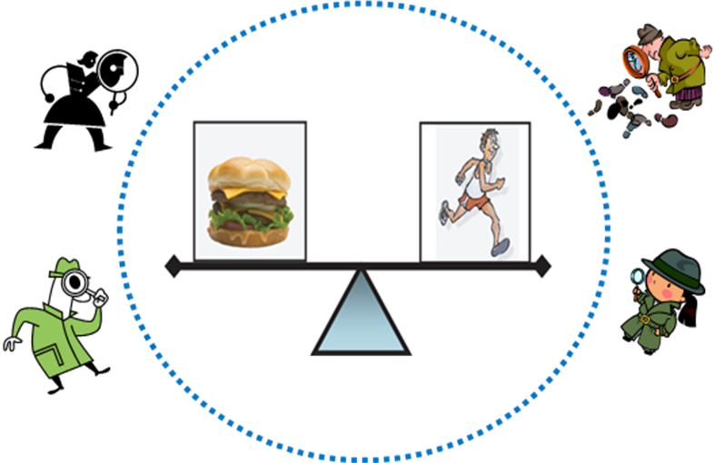

Module 1 Enduring Understanding
Epidemiology and the Energy Balance Equation
Module 1 Authentic Performance Tasks
Health and disease are not distributed haphazardly in a population. There are patterns to their occurrence that can be identified through surveillance. Analysis of the patterns of health and disease distribution can provide clues for formulating hypotheses about their possible causes.
Students will conduct and interpret a descriptive epidemiological survey among students in their class and again among students outside their class. Working in teams, students will have the opportunity to demonstrate their abilities to request informed consent, ask questions about a health-related behavior, accurately record responses, calculate prevalence of the behavior, make accurate statements about the prevalence of the behavior among their classmates, look for patterns, and formulate hypotheses based on the patterns they observe. Deliverables will include either written reports or presentations about the surveys. Specific performance criteria will be used to help ensure that the experiences allow a genuine, realistic, and fair assessment of students’ comprehension of the Module 1 Enduring Epidemiological Understanding.

Table of Contents

 | Pages
Lesson 1-1: Introduction to Curriculum (no Worksheets)
Lesson 1-2: Surveillance (no Worksheets)
Lesson 1-3: Patterns and Hypotheses
1-3a: Practice in Prevalence Calculations | 4
1-3b: Reading a Data Table and a Graph | 5
1-3c: Reading Assignment: Hypotheses about Overweight and Obesity | 6
1-3c: ANSWER SHEET | 7
1-3d: Reading Assignment: Descriptive Epidemiology of Obesity/Physical Activity | 8
1-3d: ANSWER SHEET | 11
Lesson 1-4: Describing Health-Related Behaviors in Youth
1-4a: Criteria for a Good Question | 14
1-4b: Question / Answer Form - TV-Watching | 15
1-4c Practice in Prevalence Calculations | 16
1-4d: Criteria for an Accurate Statement | 17
1-4e: Question / Answer Form - Video / Computer Games | 18
Lesson 1-5: Creating a Surveillance Question
1-5a: Creating a Question Assignment | 19
Lesson 1-6: Respect - Part 1
1-6a: Criteria for Informed Consent | 20
1-6b: Informed Consent Script Assignment | 21
Lesson 1-7: Surveillance Questions - In Class
1-7a: Steps and Expectations for Putting It All Together | 22
1-7b: Sample Surveillance Form | 23
1-7c: In-Class Survey Results Summary | 24
Lesson 1-8: Surveillance Questions - In School
1-8a: Steps and Expectations for Putting it all Together | 26
1-8b: In-School Survey Results Summary | 27
1-8c: Rubric for Evaluating Report Out and Poster | 31
1-3a
Practice in Prevalence Calculations
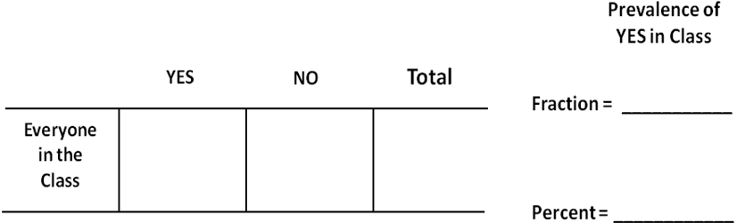

1-3b
Reading a Data Table and a Graph
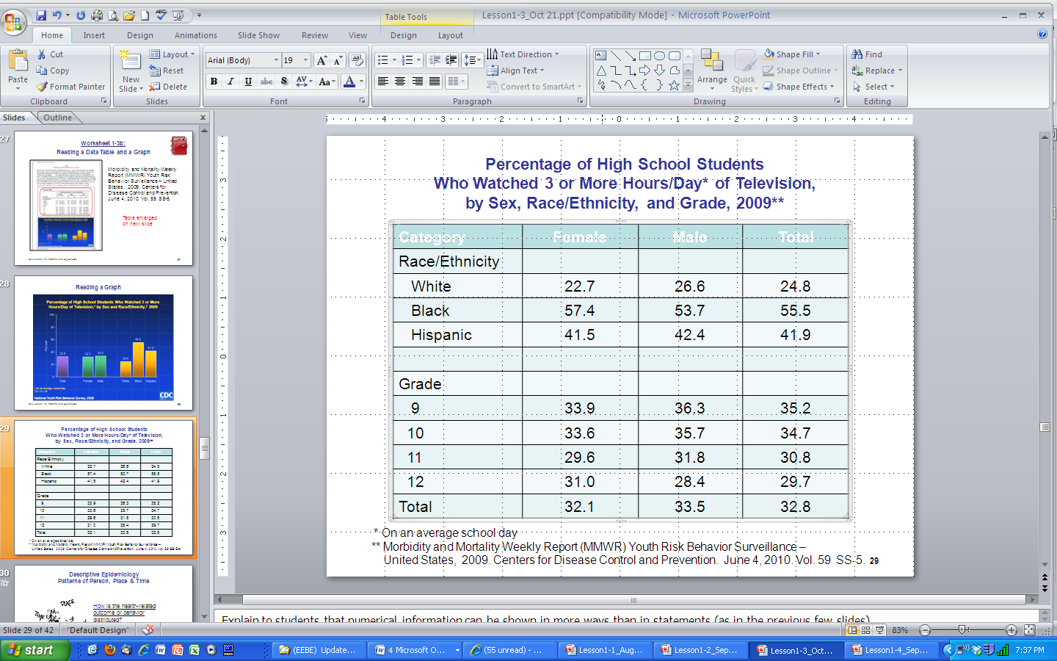
.

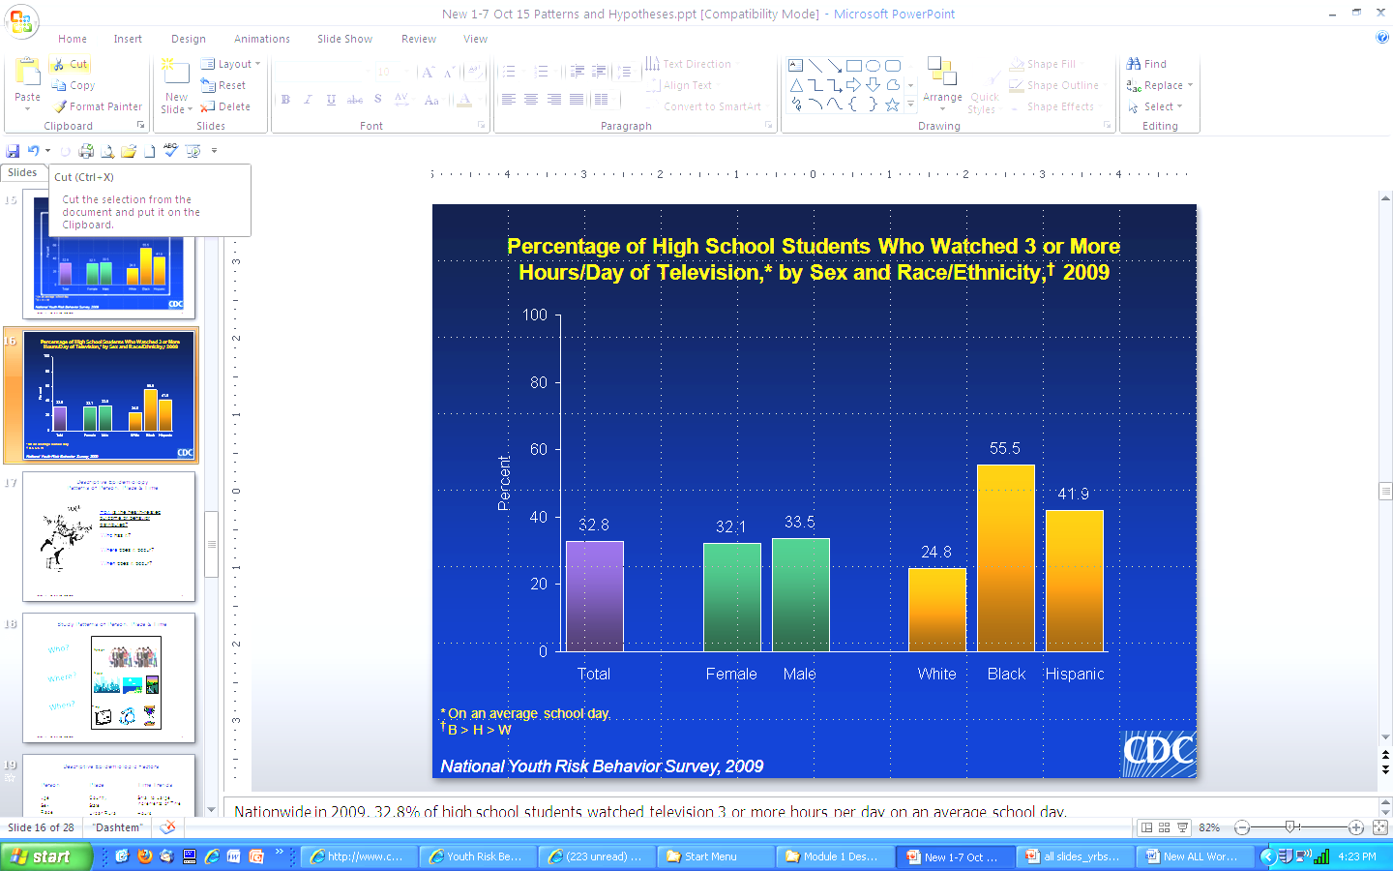
1-3c
Reading Assignment: Hypotheses about Overweight and Obesity
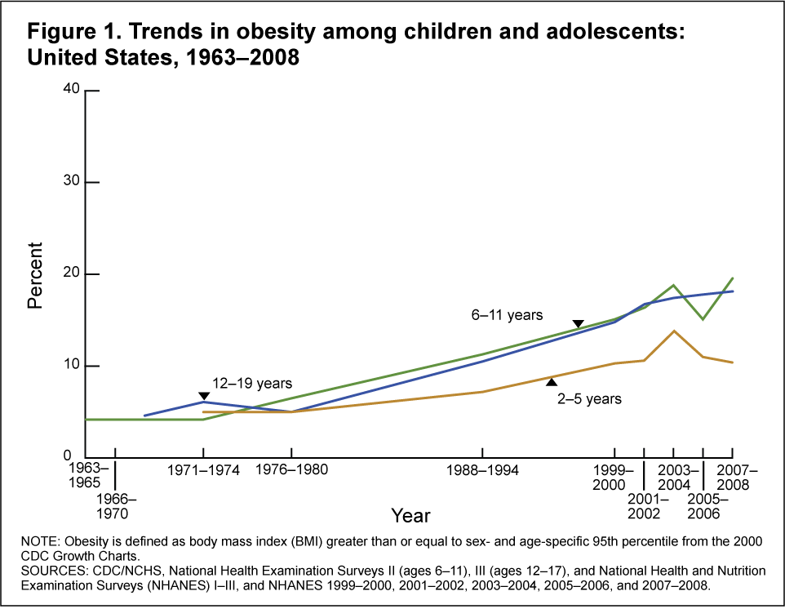
- Examine the graph. What is the overall time trend for obesity between 1976-80 and 2007-08?
Increasing? Decreasing? Steady?

- Read the remainder of the text and underline any passages that are hypotheses of “Why” these time trends are observed.
Childhood Overweight and Obesity
Excerpted and adapted from http://www.cdc.gov/obesity/defining.html

Obesity is a serious health concern for children and teenagers. In 2007–2008, the NHANES studied these age groups. (NHANES is an abbreviation for the National Health and Nutrition Examination Survey.) They measured heights and weights of many young people. The study found the following trends in obesity by age group:

YEARS | AGE 2-5 | AGE 6-11 | AGE 12-19
1976-1980 | 5% | 6½ % | 5%
1999-2000 | 10% | 20% | 18%

For the later period between 1999–2000 and 2007–8, there is a lack of a clearly increasing trend for all age groups. (http://www.cdc.gov/obesity/childhood/trends.html)

(Overweight and obesity are both labels that describe unhealthy weight for a given height. These labels also identify increased risk of certain diseases and other health problems.)

Behavioral Factors
Several behaviors can act together to cause obesity. So it is not possible to specify one behavior as the "cause" of obesity. However, certain behaviors can be identified as possibly related to energy imbalance. This can lead to obesity.

Energy intake: Energy intake is the amount of food and beverages taken in. Too much energy intake means taking in more than is needed for good health. There is limited scientific evidence on exactly what foods and diets are to blame. However, several factors are often hypothesized as contributing to excess energy intake among children and teens. These include: 1) large portion sizes for food and beverages; 2) eating meals away from home; 3) frequent snacking on energy-dense foods; and 4) drinking beverages with added sugar. More and more studies are suggesting an association between sugar-sweetened drinks, and weight gain in children and teens. Sugar-sweetened drinks may be associated with obesity because these drinks are high in calories. Also, liquid forms of energy may be less filling than solid forms and lead to eating more calories.

Physical activity: Physical activity means body movement and exercise. Physical activity is important for children and teens. It may help in controlling body weight, and also for normal blood pressure and bone strength. Children who are physically active are also more likely to stay active in their teens and as adults. Children may be spending less time engaged in physical activity during school. Daily physical education among adolescents dropped 14% in 13 years, from 42% in 1991 to 28% in 2003. In addition, less than one-third of high school students meet recommended levels of physical activity.

Sedentary behavior: Sedentary behavior means low physical activity. Children spend a lot of time with media. One study examined children 8-18 years old. It found that on average, they spent over 3 hours per day watching TV, videos, DVDs, and movies. Several studies have found a link between more TV watching and increased obesity in children. Media use, especially watching television, may replace time children could spend in physical activities. It might also contribute to increased snacking and eating meals in front of the TV. Exposure to food advertisements on TV could influence children to choose unhealthy foods. (http://www.cdc.gov/obesity/childhood/causes.html)
1-3c (ANSWER SHEET)
Reading Assignment: Hypotheses about Overweight and Obesity
- Examine the graph. What is the overall time trend for obesity between 1976-80 and 2007-08?
Increasing? Decreasing? Steady?

  - Read the remainder of the text and underline any passages that are hypotheses of “Why” these time trends are observed.

Childhood Overweight and Obesity
Excerpted and adapted from http://www.cdc.gov/obesity/defining.html

Obesity is a serious health concern for children and teenagers. In 2007–2008, the NHANES studied these age groups. (NHANES is an abbreviation for the National Health and Nutrition Examination Survey.) They measured heights and weights of many young people. The study found the following trends in obesity by age group:

YEARS | AGE 2-5 | AGE 6-11 | AGE 12-19
1976-1980 | 5% | 6½ % | 5%
1999-2000 | 10% | 20% | 18%

For the later period between 1999–2000 and 2007–8, there is a lack of a clearly increasing trend for all age groups. (http://www.cdc.gov/obesity/childhood/trends.html)

(Overweight and obesity are both labels that describe unhealthy weight for a given height. These labels also identify increased risk of certain diseases and other health problems.)

Behavioral Factors
Several behaviors can act together to cause obesity. So it is not possible to specify one behavior as the "cause" of obesity. However, certain behaviors can be identified as possibly related to energy imbalance. This can lead to obesity.

Energy intake: Energy intake is the amount of food and beverages taken in. Too much energy intake means taking in more than is needed for good health. There is limited scientific evidence on exactly what foods and diets are to blame. However, several factors are often hypothesized as contributing to excess energy intake among children and teens. These include: 1) large portion sizes for food and beverages; 2) eating meals away from home; 3) frequent snacking on energy-dense foods; and 4) drinking beverages with added sugar. More and more studies are suggesting an association between sugar-sweetened drinks, and weight gain in children and teens. Sugar-sweetened drinks may be associated with obesity because these drinks are high in calories. Also, liquid forms of energy may be less filling than solid forms and lead to eating more calories.

Physical activity: Physical activity means body movement and exercise. Physical activity is important for children and teens. It may help in controlling body weight, and also for normal blood pressure and bone strength. Children who are physically active are also more likely to stay active in their teens and as adults. Children may be spending less time engaged in physical activity during school. Daily physical education among adolescents dropped 14% in 13 years, from 42% in 1991 to 28% in 2003. In addition, less than one-third of high school students meet recommended levels of physical activity.

Sedentary behavior: Sedentary behavior means low physical activity. Children spend a lot of time with media. One study examined children 8-18 years old. It found that on average, they spent over 3 hours per day watching TV, videos, DVDs, and movies. Several studies have found a link between more TV watching and increased obesity in children. Media use, especially watching television, may replace time children could spend in physical activities. It might also contribute to increased snacking and eating meals in front of the TV. Exposure to food advertisements on TV could influence children to choose unhealthy foods. (http://www.cdc.gov/obesity/childhood/causes.html)
1-3d
Reading Assignment: Descriptive Epidemiology of Obesity/Physical Activity

Directions: Read the pages below. There are several kinds of information presented, including some descriptive epidemiology. Underline all passages that provide information about distributions of obesity in terms of person (who), place (where) and time (when), and also about distributions of physical activity in terms of person (who), place (where) and time (when). For each area you underline, label it as person, place or time (PPT).

-------------------------------------------------------------------------------------------------------------------------

Health Topics
Physical Activity

Physical Activity and the Health of Young People

Benefits of Regular Physical Activity
- Helps build and maintain healthy bones and muscles.¹
- Helps reduce the risk of developing obesity and chronic diseases such as diabetes and cardiovascular disease.¹
- Reduces feelings of depression and anxiety and promotes psychological well-being.¹

Long-Term Consequences of Physical Inactivity
- Overweight and obesity, influenced by physical inactivity and poor diet, are significantly associated with an increased risk of diabetes, high blood pressure, high cholesterol, asthma, arthritis, and poor health status.²
- Physical inactivity increases the risk of dying prematurely, dying of heart disease, and developing diabetes, colon cancer, and high blood pressure.¹

Obesity Among Youth
- The prevalence of obesity among children aged 6–11 more than doubled in the past 20 years, going from 6.5% in 1980 to 17.0% in 2006. The rate among adolescents aged 12–19 more than tripled, increasing from 5.0% to 17.6%.³
- Children and adolescents who are overweight are more likely to be overweight or obese as adults;⁴ one study showed that children who became obese by age 8 were more severely obese as adults.⁵

1-3d (continued)

Participation in Physical Activity by Young People
- During the 7 days preceding the survey, 77% of children aged 9-13 reported participating in free-time physical activity.⁶
- Eighteen percent of high school students had participated in at least 60 minutes per day of physical activity on each of the 7 days before the survey.⁷
- Twenty-three percent of high school students did not participate in 60 or more minutes of any kind of physical activity that increased their heart rate or made them breathe hard some of the time on at least 1 day during the 7 days before the survey (i.e., did not participate in 60 or more minutes of physical activity on any day).⁷
- Participation in physical activity declines as young people age.⁷
Percentage of High School Students Participating in Physical Activity and Physical Education, by Sex, 2009⁷
Type of Activity | Girls | Boys
At least 60 minutes/day of physical activityª | 11.4% | 24.8%
Attended physical education class daily^{b} | 31.9% | 34.6%

ª Any kind of physical activity that increased heart rate and made them breathe hard some of the time for at least 60 minutes per day on each of the 7 days before the survey
^{b}Attended physical education classes 5 days in an average week when they were in school

Participation in Physical Education Classes
- Over half (56%) of high school students (72% of 9th grade students but only 44% of 12th grade students) attended physical education classes in 2009.⁷
- The percentage of high school students who attended physical education classes daily decreased from 42% in 1991 to 25% in 1995, and has remained stable at that level until 2009 (33%). In 2009, 47% of 9th grade students but only 22% of 12th grade students attended physical education class daily.⁷

1-3d (continued)
References
- U.S. Department of Health and Human Services. Physical activity guidelines advisory committee report. Washington, DC: U.S. Department of Health and Human Services, 2008.
- Mokdad AH, Ford ES, Bowman BA, et al. Prevalence of obesity, diabetes, and obesity-related health risk factors, 2001. Journal of the American Medical Association 2003;289 (1):76-79.
- Ogden CL, Carroll MD, Flegal KM. High Body Mass Index for Age among US Children and Adolescents, 2003-2006. JAMA. 2008; 299 (20):2401-2405.
- Ferraro KF, Thorpe RJ Jr, Wilkinson JA. The life course of severe obesity: Does childhood overweight matter? Journal of Gerontology 2003; 58B (2):S110-S119.
- Freedman DS, Khan LK, Dietz WH, Srinivasan SR, Berenson GS. Relationship of childhood obesity to coronary heart disease risk factors in adulthood: the Bogalusa Study. Pediatrics 2001; 108 (3):712-718.
- CDC. Physical activity levels among children aged 9–13 years—United States, 2002. Morbidity and Mortality Weekly Report August 22, 2003; 52 (SS-33): 785-788.
- CDC. Youth Risk Factor Surveillance – United States, 2009. [PDF 3.5M MMWR 2010; 59 (SS-5):1-142.

WebPage last modified: May 10, 2010, Downloaded on August 23, 2010
Content Source: National Center for Chronic Disease Prevention and Health Promotion, Division of Adolescent and Child Health
http://www.cdc.gov/healthyyouth/physicalactivity/facts.htm
1-3d (ANSWER SHEET)
Reading Assignment: Descriptive Epidemiology of Obesity/Physical Activity

Directions: Read the pages below. There are several kinds of information presented, including some descriptive epidemiology. Underline all passages that provide information about distributions of obesity in terms of person (who), place (where) and time (when), and also about distributions of physical activity in terms of person (who), place (where) and time (when)). For each area you underline, label it as person, place or time. (PPT) Answer sheet – person=yellow, place=blue, time=green

-------------------------------------------------------------------------------------------------------------------------

Health Topics
Physical Activity

Physical Activity and the Health of Young People

Benefits of Regular Physical Activity
- Helps build and maintain healthy bones and muscles.¹
- Helps reduce the risk of developing obesity and chronic diseases such as diabetes and cardiovascular disease.¹
- Reduces feelings of depression and anxiety and promotes psychological well-being.¹

Long-Term Consequences of Physical Inactivity
- Overweight and obesity, influenced by physical inactivity and poor diet, are significantly associated with an increased risk of diabetes, high blood pressure, high cholesterol, asthma, arthritis, and poor health status.²
- Physical inactivity increases the risk of dying prematurely, dying of heart disease, and developing diabetes, colon cancer, and high blood pressure.¹

Obesity Among Youth
- The prevalence of obesity among children aged 6–11 more than doubled in the past 20 years, going from 6.5% in 1980 to 17.0% in 2006. The rate among adolescents aged 12–19 more than tripled, increasing from 5.0% to 17.6%.³
- Children and adolescents who are overweight are more likely to be overweight or obese as adults;⁴ one study showed that children who became obese by age 8 were more severely obese as adults.⁵

1-3d (ANSWER SHEET) (continued)

Participation in Physical Activity by Young People
- During the 7 days preceding the survey, 77% of children aged 9-13 reported participating in free-time physical activity.⁶
- Eighteen percent of high school students had participated in at least 60 minutes per day of physical activity on each of the 7 days before the survey.⁷
- Twenty-three percent of high school students did not participate in 60 or more minutes of any kind of physical activity that increased their heart rate or made them breathe hard some of the time on at least 1 day during the 7 days before the survey (i.e., did not participate in 60 or more minutes of physical activity on any day).⁷
- Participation in physical activity declines as young people age.⁷
Percentage of High School Students Participating in Physical Activity and Physical Education, by Sex, 2009⁷
Type of Activity | Girls | Boys
At least 60 minutes/day of physical activityª | 11.4% | 24.8%
Attended physical education class daily^{b} | 31.9% | 34.6%

ª Any kind of physical activity that increased heart rate and made them breathe hard some of the time for at least 60 minutes per day on each of the 7 days before the survey
^{b}Attended physical education classes 5 days in an average week when they were in school

Participation in Physical Education Classes
- Over half (56%) of high school students (72% of 9th grade students but only 44% of 12th grade students) attended physical education classes in 2009.⁷
- The percentage of high school students who attended physical education classes daily decreased from 42% in 1991 to 25% in 1995, and has remained stable at that level until 2009 (33%). In 2009, 47% of 9th grade students but only 22% of 12th grade students attended physical education class daily.⁷

1-3d (ANSWER SHEET) (continued)
References
- U.S. Department of Health and Human Services. Physical activity guidelines advisory committee report. Washington, DC: U.S. Department of Health and Human Services, 2008.
- Mokdad AH, Ford ES, Bowman BA, et al. Prevalence of obesity, diabetes, and obesity-related health risk factors, 2001. Journal of the American Medical Association 2003; 289 (1):76-79.
- Ogden CL, Carroll MD, Flegal KM. High Body Mass Index for Age among US Children and Adolescents, 2003-2006. JAMA. 2008; 299 (20):2401-2405.
- Ferraro KF, Thorpe RJ Jr, Wilkinson JA. The life course of severe obesity: Does childhood overweight matter? Journal of Gerontology 2003; 58B(2):S110-S119.
- Freedman DS, Khan LK, Dietz WH, Srinivasan SR, Berenson GS. Relationship of childhood obesity to coronary heart disease risk factors in adulthood: the Bogalusa Study. Pediatrics 2001;108(3):712-718.
- CDC. Physical activity levels among children aged 9–13 years—United States, 2002. Morbidity and Mortality Weekly Report August 22, 2003; 52 (SS-33): 785-788.
- CDC. Youth Risk Factor Surveillance – United States, 2009. [PDF 3.5M MMWR 2010;59(SS-5):1-142.

WebPage last modified: May 10, 2010, Downloaded on August 23, 2010
Content Source: National Center for Chronic Disease Prevention and Health Promotion, Division of Adolescent and Child Health
http://www.cdc.gov/healthyyouth/physicalactivity/facts.htm

1-4a
Criteria for a Good Question

 | Criteria | Met | Somewhat Met | Not Met
1. | It should be clear and unambiguous, written so that its intended audience understands it | □ | □ | □
2. | It should mean the same thing to everyone who reads it. In other words, if 100 students all behave the same way they must all select the same answer. (For example, if the only television that 100 students watch on the average school day is when they pause as they walk through the living room to watch a news report for 2 minutes before returning to their room to do their home work, then all 100 such students should select the same answer.) | □ | □ | □
3. | The answer options categorize and cover the entire range of possible behavior (from complete absence of the behavior to a maximum amount of the behavior) | □ | □ | □
4. | The time period to consider when answering a particular question must be appropriate. It should be long or short enough to capture the frequency of behavior desired. Depending on the information desired and the type of behavior, this could be infrequent but important behavior (“during your life,” “during the past 12 months,” “during the past 3 months,”). Or it could be more recent behavior such as “during the past 30 days,” “during the past 7 days,” “yesterday,” or “today”) | □ | □ | □
5. |  | □ | □ | □
6. |  | □ | □ | □

1-4b
Question / Answer Form - TV-Watching

DO NOT WRITE YOUR NAME ON THIS FORM.

On an average school day, how many hours do you watch TV?

 | A. | I do not watch TV on an average school day
 | B. | Less than 1 hour per day
 | C. | 1 hour per day
 | D. | 2 hours per day
 | E. | 3 hours per day
 | F. | 4 hours per day
 | G. | 5 or more hours per day

===================== cut here ======================

DO NOT WRITE YOUR NAME ON THIS FORM.

On an average school day, how many hours do you watch TV?

 | A. | I do not watch TV on an average school day
 | B. | Less than 1 hour per day
 | C. | 1 hour per day
 | D. | 2 hours per day
 | E. | 3 hours per day
 | F. | 4 hours per day
 | G. | 5 or more hours per day
1-4c
Practice in Prevalence Calculations


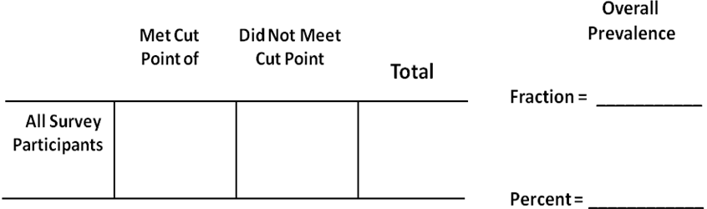
Television-Watching

During __________________, among __________________, in __________________

class, ________._____% had ______________________________________________ .

Computer or Video Games Use

During __________________, among __________________, in __________________

class, ________._____% had ______________________________________________

1-4d
Criteria for an Accurate Statement

 | Criteria | Met | Somewhat Met | Not Met
1. | Identifies the group of people to whom the statement applies | □ | □ | □
2. | Identifies the time period for which the statement applies | □ | □ | □
3. | It is expressed as a proportion or a percentage rather than a count | □ | □ | □
4. |  | □ | □ | □
5. |  | □ | □ | □
6. |  | □ | □ | □
7. |  | □ | □ | □

1-4e
Question / Answer Form - Video / Computer Games

DO NOT WRITE YOUR NAME ON THIS FORM.

On an average school day, how many hours do you play video or computer games or use a computer for something that is not school work? (Include activities such as Nintendo, Game Boy, PlayStation, computer games, and the Internet.)

 | A. | I do not play video or computer games or use the computer for something that is not school work
 | B. | Less than 1 hour per day
 | C. | 1 hour per day
 | D. | 2 hours per day
 | E. | 3 hours per day
 | F. | 4 hours per day
 | G. | 5 or more hours per day
===================== cut here ======================

DO NOT WRITE YOUR NAME ON THIS FORM.

On an average school day, how many hours do you play video or computer games or use a computer for something that is not school work? (Include activities such as Nintendo, Game Boy, PlayStation, computer games, and the Internet.)

 | A. | I do not play video or computer games or use the computer for something that is not school work
 | B. | Less than 1 hour per day
 | C. | 1 hour per day
 | D. | 2 hours per day
 | E. | 3 hours per day
 | F. | 4 hours per day
 | G. | 5 or more hours per day

1-5a
Creating a Question Assignment

Names of Students on Study Team:

________________________________________
________________________________________
________________________________________
________________________________________

Write a question that would allow you to count the frequency of the health-related behavior identified below and make an accurate statement about its prevalence among students who have given their informed consent to participate in the research simulation.

_________________________________

Assigned Health-Related Behavior

Question_______________________________________________________________
_________________________________________________________________
_________________________________________________________________
_________________________________________________________________
_________________________________________________________________

 | A. | ___________________________________________________
 | B. | ___________________________________________________
 | C. | ___________________________________________________
 | D. | ___________________________________________________
 | E. | ___________________________________________________
 | F. | ___________________________________________________
 | G. | ___________________________________________________
1-6a
Criteria for Informed Consent

 | CRITERIA | MET | SOMEWHAT MET | NOT MET
1. | Purpose of the study
2. | What study participants will experience
3. | Any reasonably foreseeable risks to the individual
4. | Potential benefits to the individual
5. | Potential benefits to others
6. | The extent of confidentiality protections for the individual
7. | Compensation for participation (may include money, other material compensation, such as a coupon or gift certificate, or other non-monetary rewards)
8. | Contact information for questions regarding the study, participants’ rights, and in case of Injury
9. | The conditions of participation, including right to refuse or withdraw without penalty
10.

1-6b
Informed Consent Script Assignment

Names of Students on Study Team:

________________________________________
________________________________________
________________________________________
________________________________________

Write an Informed Consent script that you, as the investigation team, will read during a research simulation in which you will ask other students to answer questions about a health-risk behavior.

Make sure your Informed Consent Script addresses the Belmont Report requirements of disclosure, comprehension, and voluntariness.

Use Worksheet 1-6a, Criteria for Informed Consent, for guidance in writing your script.

Remember that informed consent is an agreement that is given by a potential research participant following an explanation of all relevant information that is needed to make a decision about participating in a study. This information includes the purpose, risks, and potential benefits of the research so that people can make an informed, voluntary decision about whether or not to participate, based on their own goals and values. All information about the study needs to be stated in a way that potential participants can understand.

1-7a
Steps and Expectations for Putting It All Together

 | Steps and Expectation | Met | Somewhat Met | Not Met
1. | Asking for informed consent:  - Informed consent script provides classmates with all the information they need to voluntarily decide whether or not they wish to participate based on their own goals and values | □ | □ | □
2. | Asking questions:  - Questions are clearly stated so that classmates understand them, they will mean the same thing to everyone who reads them, and they will categorize and cover the entire range of possible behavior | □ | □ | □
3. | Counting:  - Counts are accurate | □ | □ | □
4. | Calculating prevalence of health behavior:  - Prevalence calculation is accurate and has properly handed missing answers | □ | □ | □
5. | Writing statements:  - Statements accurately describe the overall prevalence of the health-related behavior  - Be able to complete the following statement about their health-related behavior: During ________________, among ________________, in ________________ class, XX.X% had ________________ . | □ | □ | □
6. | Formulating hypotheses:  - Hypotheses are “educated guesses” | □ | □ | □
7. | Reporting out to others in class  - Reporting is accurate and clear
8.

1-7b
Sample Surveillance Form

Thank you for your participation in this brief survey. Please answer the questions below by circling one choice for each question. When you are finished, fold this paper in half and follow instructions for handing in your questionnaire.

Remember: Do not write your name anywhere on this paper.

1. Write the health behavior question here and the answer choices below

(Circle one answer below)

A.

B.

C.

D.

E.

F.

G

- Are you female or male?

(Circle one answer) FEMALE MALE
Note to epidemiology students: After you have filled in the information on this sheet, your teacher will give you a WORD document on the computer for your to type the actual Surveillance Form for your study participants.

1-7c
In-Class Survey Results Summary

- State the health-related question ___________________________________________
_____________________________________________________________________

- How many people answered the question? ________________
- Any blanks or other answers (if yes, how many?) ________________
- Having chosen your cut point before the survey was conducted, sort all the survey sheets into two piles – one pile for everyone who met the cut point, and the other pile for everyone who did not meet the cut point.
How many participants met the cut point? _________
How many participants did not meet the cut point? __________
- Label and fill in the table below and calculate prevalence of the health behavior.
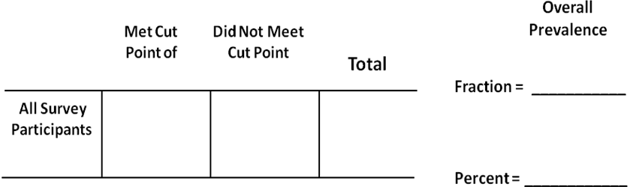

- Make a statement about the prevalence of the health behavior. Be sure your statement follows all the criteria for an accurate statement :
- Identifies the group of people to whom the statement applies
- Identifies the time period for which the statement applies
- Is expressed as a proportion or a percentage rather than a count.
fraction x/y = z percent)

Write your prevalence statement here: ____________________________________

____________________________________________________________________

1-7c (continued)

- How did you account for the students who did not answer the question?

- How did you account for the students who were absent from class?

- How did you decide on where to “cut” your data? (This should have been decided in Lesson 1-5, when you were developing your survey.)

- Do you have any hypotheses based on your prevalence statement?

- How would you change/improve your survey next time?

1-8a
Steps and Expectations for Putting It All Together

 | Steps and Expectation | Met | Somewhat Met | Not Met
 | Study Prep: Work with Teacher to define study population consisting of other class(es)
1. | Asking for informed consent:  - Informed consent script provides classmates with all the information they need to voluntarily decide whether or not they wish to participate based on their own goals and values | □ | □ | □
2. | Asking questions:  - Questions are clearly stated so that classmates understand them, they will mean the same thing to everyone who reads them, and they will categorize and cover the entire range of possible behavior | □ | □ | □
3. | Counting:  - Counts are accurate | □ | □ | □
4. | Calculating prevalence of health behavior for all and by gender:  - Prevalence calculations are accurate and have properly handed missing answers | □ | □ | □
5. | Writing statements:  - Statements accurately describe the overall prevalence of the health-related behavior  - Be able to complete the following statement about their health-related behavior: During ________________, among ________________, in ________________ class, XX.X% had ________________ . | □ | □ | □
6. | Formulating hypotheses:  - Hypotheses are “educated guesses” | □ | □ | □
7. | Summarizing results  - Results are accurately presented in statements, a table, and a bar graph | □ | □ | □
8. | Reporting out to classmates and study participants:  - Reporting is accurate and clear | □ | □ | □
1-8b
In-School Survey Results Summary

- State the health-related question ___________________________________________
_____________________________________________________________________

- How many people answered the question? ________________
- Any blanks or other answers (if yes, how many?) ________________
- Having chosen your cut point before the survey was conducted, sort all the survey sheets into two piles – one pile for everyone who met the cut point, and the other pile for everyone who did not meet the cut point.
How many participants met the cut point? _________
How many participants did not meet the cut point ? __________
- Label and fill in the table below and calculate prevalence of the health behavior.

- Make a statement about the prevalence of the health behavior. Be sure your statement follows all the criteria for an accurate statement :
- Identifies the group of people to whom the statement applies
- Identifies the time period for which the statement applies
- Is expressed as a proportion or a percentage rather than a count. nominator = fraction x/y = z percent)

Write your prevalence statement here: ____________________________________

___________________________________________________________________

1-8b (continued)
In-School Survey Results Summary

- Re-sorting of survey sheets by gender:
- How many people answered the gender question (MALE or FEMALE?) ___________
- Any blanks or other answers (if yes, how many?) ___________
- Re-sort the survey sheets into two piles - one pile for everyone who answered FEMALE, and the other pile for everyone who answered MALE.

- Analysis of FEMALES separately
- How many participants answered FEMALE? _________
- For the FEMALE pile, sort further into two piles - one pile for those who met the cut point, and the other pile for those who did not meet the cut point.
- Label and fill in the tables below, and calculate prevalence of the health behavior among FEMALES.
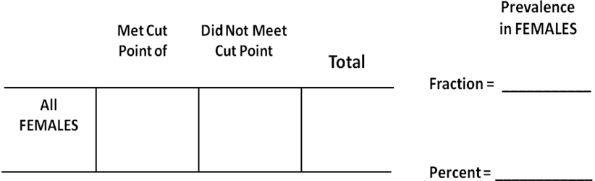

- Make a statement about the prevalence of the health-related behavior among FEMALES. Be sure your statement follows all the criteria for an accurate statement :

Write your prevalence statement for FEMALES here: ____________________________

____________________________________________________________________
1-8b (continued)
In-School Survey Results Summary

- Analysis of MALES separately:
- How many participants answered MALE? __________
- For the MALE pile, sort further into two piles - one pile for those who met the cut point, and the other pile for those who did not meet the cut point.
- Label and fill in the table below, and calculate prevalence of the health behavior among MALES.
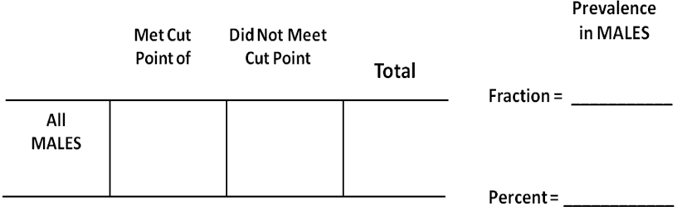

- Make a statement about the prevalence of the health behavior among MALES. Be sure your statement follows all the criteria for an accurate statement.

Write your prevalence statement for MALES here: ______________________________

____________________________________________________________________

- How were the results for FEMALES and MALES similar or different?

- What hypotheses might explain the pattern or lack of a pattern by gender?

1-8b (continued)
In-School Survey Results Summary

- Display your surveillance results in the table below.
(Write Title of Table)

 | OVERALL STUDY GROUP | FEMALES | MALES
Number in numerator
Number in denominator
PREVALENCE (%)

- Display your surveillance results by properly labeling the graph below and drawing bar graphs for the overall prevalence of your health-related behavior, and prevalence of the subgroups of females and males. Pattern your graph after the graph in 1-3b.
(Write Title of Graph)

(Label and draw scale)

(Label Bars)
- Based on your experience, how would you conduct your study differently next time?

1-8c
Rubric for Evaluating Report Out and Poster

Instructions: Working as a study team and using information from your in-school survey, prepare a written report or an oral presentation of your in-school survey. Work with your teacher to determine whether this will be a report or presentation, its approximate length, and who the audience will be (such as students, teachers, parents).

The content should include your methods and results, possible hypotheses that have been generated, and your views on the strengths and limitations of your survey. (Much of this can be taken from 1-8b.)

The rubric below will be used by the teacher to assess your report/presentation, and also for the study teams to perform self-assessments

Criteria | Got It | Getting It | Will Get It Soon
Participation | All study team members participate | Most study team members participate | Some study team members participate
Use of epidemiology terminology such as prevalence and surveillance | All are appropriate and accurate | Most are appropriate and accurate | Some are appropriate and accurate
Accurate calculation of prevalence (either fraction or percentage) | All prevalence measures correctly calculated | Most prevalence measures correctly calculated | Few to no prevalence measures correctly calculated
Understanding of analysis by gender | Explanation of gender analysis is clear and accurate | Explanation of gender analysis is either unclear or inaccurate | Explanation of gender analysis is not clear or accurate
Generation of reasonable and/or interesting hypotheses | 1 or more hypotheses make sense in light of survey results | 1 or more hypotheses make limited sense in light of survey results | 1 or more hypotheses make little or no sense in light of survey results
Understanding of limitations of their survey | Identified at least 2 reasonable and logical limitations | Identified 1 reasonable and logical limitation | Did not identify any reasonable or logical limitations

